[**Power Clean**](https://www.youtube.com/watch?v=zz9IafDiYSQ&feature=youtu.be)

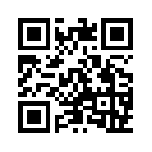

[**Barbell Push Jerk**](https://www.youtube.com/watch?v=6xdQlgxuXR0&feature=youtu.be)

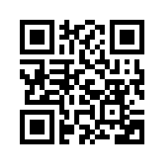

[**Clean Grip Pull to Knee**](https://youtu.be/TBfcn3SdaiA)

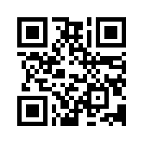

[**Mid Thigh Hang Power Clean**](https://www.youtube.com/watch?v=yVqfzmIIemw&feature=youtu.be)

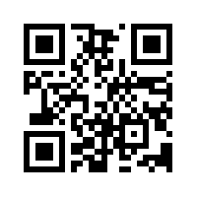

[**Hang Power Clean from Below Knee**](https://www.youtube.com/watch?v=whyL3gBSH8M&feature=youtu.be)

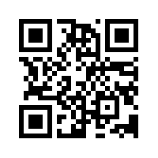

[**Mid Thigh Hang Power Clean**](https://www.youtube.com/watch?v=yVqfzmIIemw&feature=youtu.be)

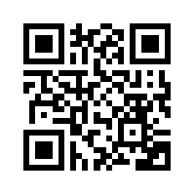

[**Clean Grip Mid Thigh Pull**](https://www.youtube.com/watch?v=jBlw9uvgMLs&feature=youtu.be)

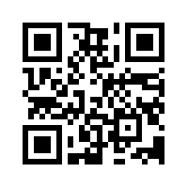

[**Power Snatch**](https://www.youtube.com/watch?v=6dKtgdn5QAM&feature=youtu.be)

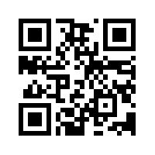

[**Snatch Grip Pull**](https://www.youtube.com/watch?v=UhVat-uJ1k8&feature=youtu.be)

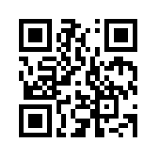

[**Snatch Grip Pull to Knee**](https://www.youtube.com/watch?v=HE4R1_DsT6A&feature=youtu.be)

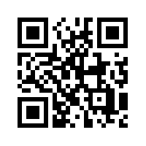

[**Snatch Grip Pull from Below Knee**](https://www.youtube.com/watch?v=_7UzM3escKQ&feature=youtu.be)

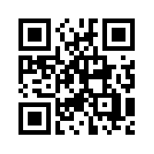

[**Mid Thigh Hang Power Snatch**](https://www.youtube.com/watch?v=g1MgmZq-q7A&feature=youtu.be)

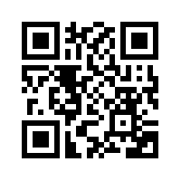

[**Snatch Grip Mid Thigh Pull**](https://www.youtube.com/watch?v=z9KUxg-fX-o&feature=youtu.be)

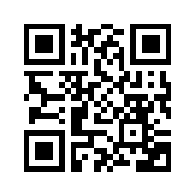

[**Barbell High Bar Back Squat**](https://www.youtube.com/watch?v=bEaLySjhDDc&feature=youtu.be)

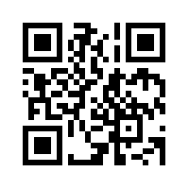

[**Barbell Low Bar Back Squat**](https://www.youtube.com/watch?v=ZB5wq88VKhw&feature=youtu.be)

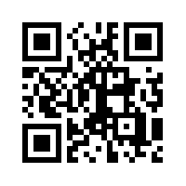

[**Dumbbell Goblet Squat**](https://www.youtube.com/watch?v=oSR7I5_D6po&feature=youtu.be)

